

Bansilal Ramnath Agarwal Charitable Trust’s

# Vishwakarma Institute of Information Technology

**PROJECT REPORT**

Business Intelligence and Data Analytics

|  |  |  |  |
| --- | --- | --- | --- |
| Name | Roll No. | GR No. | Batch |
| Chetan Chinchulkar | 324017 | 21810350 | E9 (Comp D) |
| Nikit Gokhe | 324022 | 21810522 | E9 (Comp D) |
| Sahil Langha | 324032 | 21810533 | E9 (Comp D) |
| Kunal Parkhe | 324040 | 21810049 | E9 (Comp D) |

GROUP MEMBERS:

# Index

|  |  |  |
| --- | --- | --- |
| SR No. | Name | Page No. |
| 01. | Aim | 3 |
| 02. | Problem Statement | 3 |
| 03. | Objectives | 3 |
| 04. | Dataset | 4 |
| 05. | Result & Analysis | 5 |
| 06. | Inferences & Conclusions | 10 |

# Aim:

To develop a Mini Project for any suitable case study and use all the concepts used in assignment 1 to 5 and theory concepts included in BDA theory.

# Problem Statement:

The [COVID-19 pandemic](https://en.wikipedia.org/wiki/COVID-19_pandemic) has had far-reaching consequences beyond the spread of the disease itself. As the pandemic spreads, global conferences and events across technology, fashion, and sports are being cancelled or postponed. All this event affected the GDP of most of the countries across the globe and affecting the Economies. At the start of current pandemic situation i.e. in March 2020, more than 10 million Americans lost their jobs and applied for government aid. The [lockdown in India](https://en.wikipedia.org/wiki/COVID-19_lockdown_in_India) has left tens of millions of migrant workers unemployed.

In other words, we are going study the impact of current pandemic & lockdown situation on economies and unemployment issues due to it particularly in US.

# Objectives:

* To analyse the US economy and where it would have been if the pandemic did not occur.
* To create dashboards using visualisation tools.

1. Analysis of US economy if Pandemic did not Occur.
2. Analysis of Actual situation in current pandemic

i.e. effects on GDP and Employment rate

* To deploy our results & analysis (i.e. Dashboards) on webpage.
* To analysing some factors that help us to understand economy and recession. To check whether we could predict the recession.

# Dataset:

**NAME:**

1. Bond-yield-US
2. US-employment
3. US-GDP-year
4. House-prices-US
5. Map-data

Region wise Pandemic Effect (GDP change in %, June unemployment rate)

**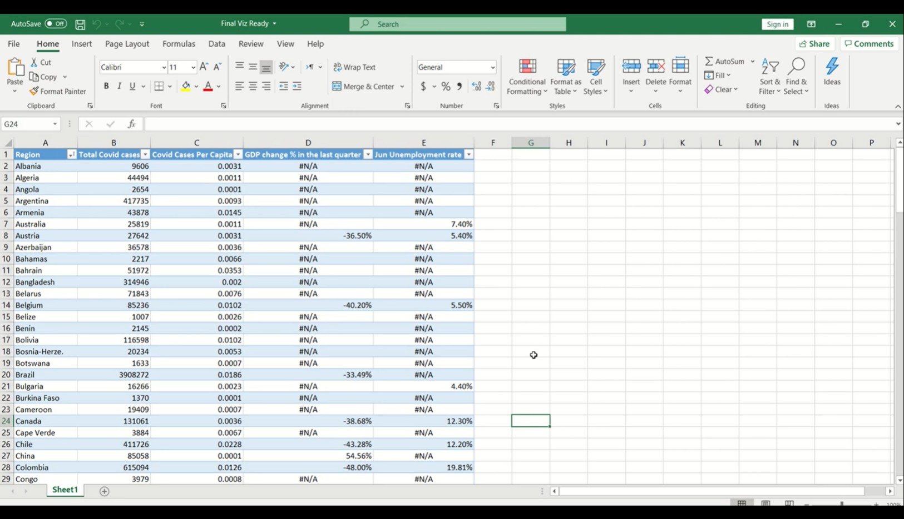  
map-data**

# Analysis & Results:

Analysis of US economy if Pandemic did not Occur.

1.

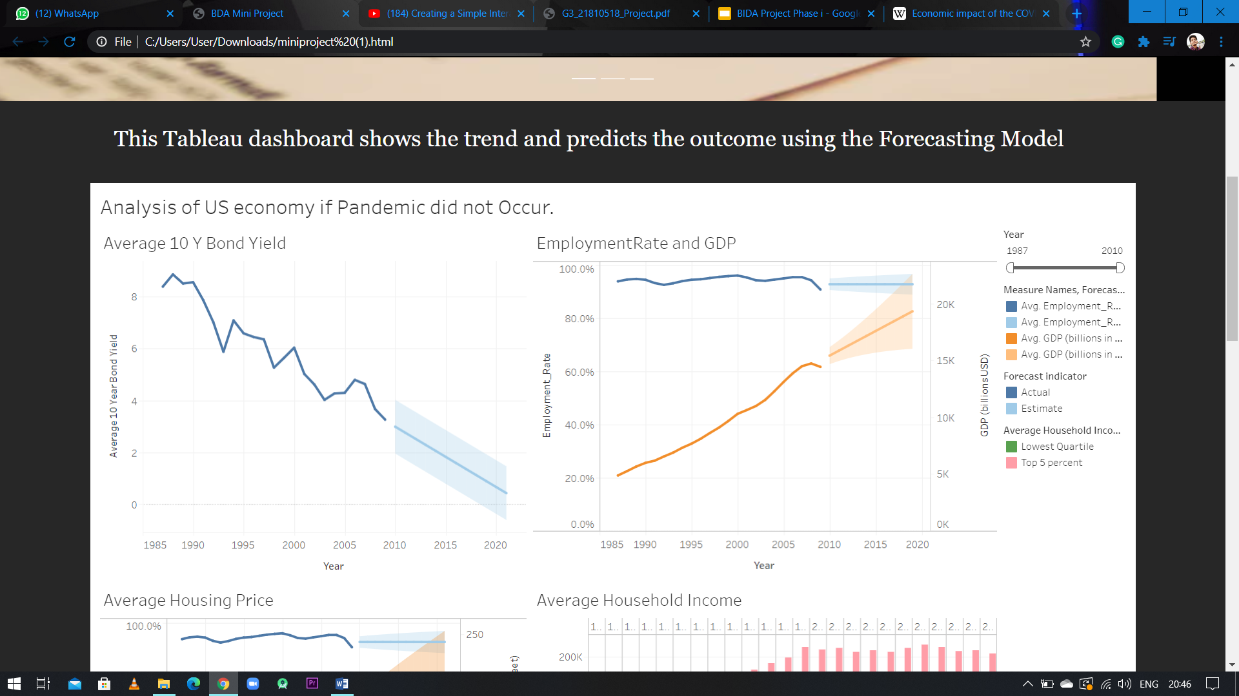

2.





3.

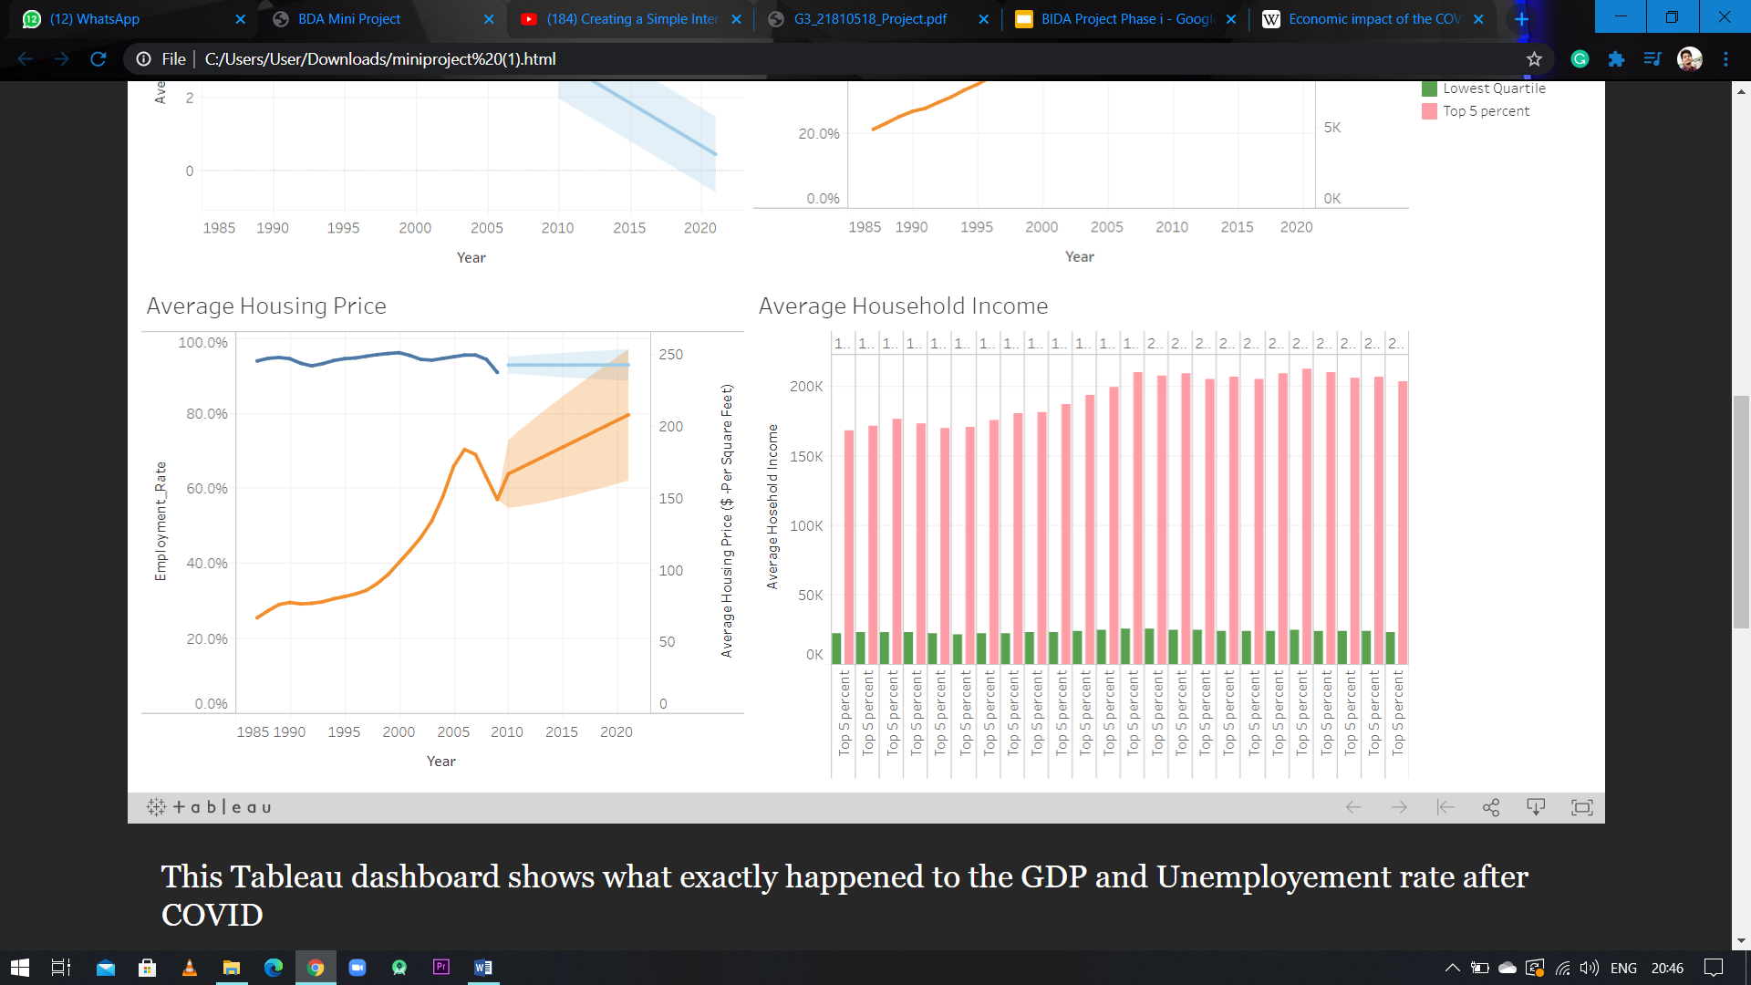

4.



Analysis of Actual situation

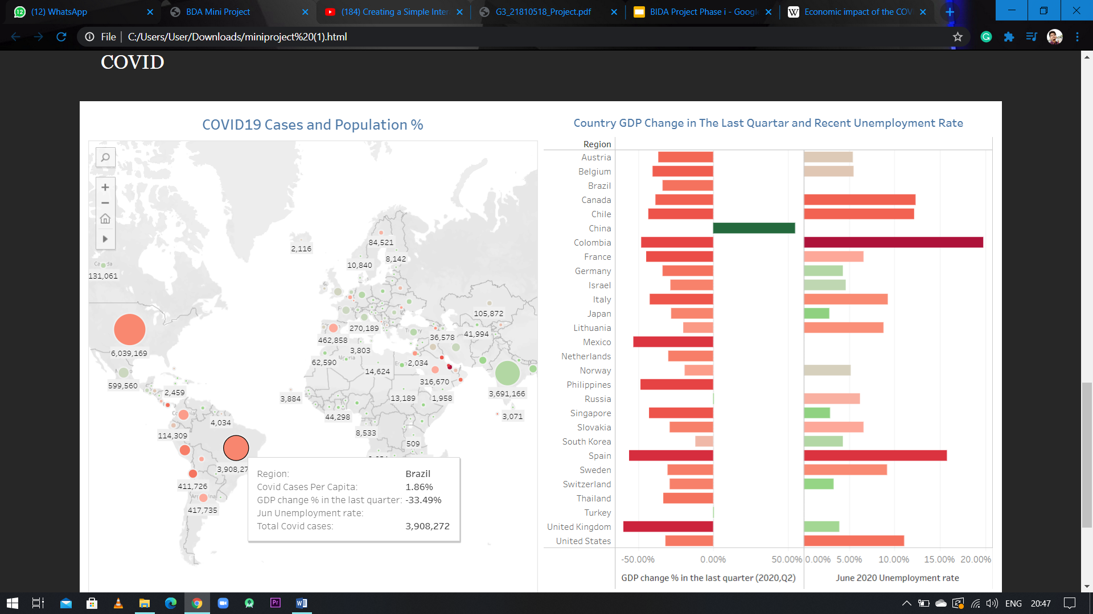1.

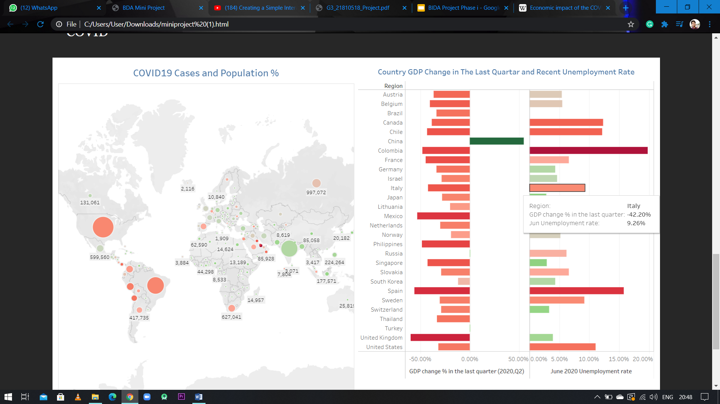2.

# Inferences & Conclusion:

# (What would have happened to US economy if the Pandemic did not occur i.e. first graph)

There are many factors that help us analyse the economy. The factors that we have considered are the average 10 Year bond, employment rate, house pricing and average household income of top 5% of the country year wise and that of lowest quartile.

* In the very first sheet of 10 Year bond yield, we have plotted it up to 2010 and then using the forecasting mode tried to estimate what the condition will be like for the next decade that is from 2010-2020 and we can see that it is taking a huge dip.
* In the second sheet we have plotted the employment rate year wise up to 2010 and predicted it for the next decade i.e. from 2010-2020 and it shows spiked employment rate and the change is of 2.7% which is huge.
* Also we have plotted the GDP curve up to 2010 and using forecasting model predicted it for the next decade. It shows that there is an increase in GDP from almost 14.5k Billion US dollars to 19.2k Billion US dollars which is a spike of almost 4.7k billion US dollars.
* The average house pricing goes form 164 USD per square feet to 201USD per square feet.
* There is not a much of change in the household income of the lower quartile but the income of top 5% goes on increasing every year.

Now this shows that US Economy would have done a lot better if the CORONA VIRUS PANDEMIC did not occur, but we can see in the second dashboard that there is a dip of almost 32 % to the US economy and UK economy struggles with the dip of -36%.

The reason our focus is on US economy is because US is hub of almost everything that is required in the present world and contributes almost 20% to the world's economy. So our final conclusion is that there is no historical data that can predict the recession. because recession occurs due to the instantaneous activities that occur, in this case CORONA VIRUS PANDEMIC.